Electrical Shock and Arc Flash Policy

Contents
Introduction 3
1. Objectives 4
2. Definitions 4
3. Workers, this Policy is intended to Protect. 5
4. Workers who can perform work on Main Disconnects 6
5. Workers who can perform work on Intermediate Disconnects 6
6. Hazard Assessment 7
7. Personal protective equipment (PPE) 7
8. Equipment Maintenance and Inspection 9
9. Emergency Procedures 9
10. Safety Watch 10
11. Responsibilities 10
12. Wet & Conductive Locations 10
13. Procedure 11
13.1 Main power disconnect 11
13.2 Intermediate Switch Gear 11
14. Limits of Approach 12
14.1Approach Boundaries 12
14.2 Main Gear Restricted Approach Boundary 12
14.3 Restricted approach boundary for Intermediate Gear 12
14.4 Limited approach boundary 13
14.5 Arc Flash Boundary 13
Conclusion 14
Appendix 15
Table 6A – PPE 15
Table 6C – PPE 16
Table O - Approach Distances 17
Table N – PPE, Tools, & Equipment 19
Revisions 20

Introduction
At (company), safety isn’t just a priority—it’s our unwavering commitment. As we operate in an environment where electrical hazards are ever-present, addressing the risks associated with arc flash incidents becomes paramount.
Understanding Arc Flash
An arc flash is a sudden and violent release of energy caused by an electrical fault. When it occurs, extreme temperatures, pressure waves, and intense light can result. The consequences can be severe, including injuries or even loss of life. As responsible professionals, we must take every precaution to prevent such incidents.
Our Policy in Action
This policy serves as our guide to maintaining a secure work environment. Here’s how we put it into practice:
- Adherence to Standards:
- We strictly adhere to industry standards, including the CSA Z462-21.
- All information, calculations, and tables are based on this authoritative source.

- Risk Mitigation:
- We identify potential arc flash hazards and take proactive measures to reduce risks.
- Our goal is to prevent incidents before they occur.

- Training and Awareness:
- We provide comprehensive training to our team members.
- Everyone understands the importance of arc flash prevention and their role in achieving it.

- Emergency Preparedness:
- In the event of an arc flash, we have clear emergency procedures.
- Our personnel know how to respond swiftly and effectively.
Continuous Improvement
We review this policy regularly, consulting with our Health and Safety Committee. By staying informed, we adapt to changes, learn from incidents, and enhance our safety practices.
Let’s work together to protect each other and create a workplace where safety is non-negotiable.

- Objectives
The purpose of this document is to clearly define our commitment to the safety of all workers who may encounter electrical hazards. It specifically focuses on those responsible for operating the main switchgear in multi-family and commercial facilities.
This policy also pertains to the initial operation of all feeding switch gear in a multi-family or commercial complex.
Awareness and Training:
- Employees responsible for main switch gear operation will receive proper training on arc flash hazards, prevention, and emergency response.
- Regular toolbox talks and awareness campaigns will reinforce safe practices.

- Definitions
The following definitions apply for the purposes of this Policy:
Affected worker: a worker who is not directly involved in the work requiring the hazardous energy control, but who is (or may be) located in the work area.
Arc flash hazard: a dangerous condition associated with the possible release of energy caused by an electric arc.
Authorized worker: a worker who is qualified because of knowledge, training, and experience and has been assigned to perform lockout.
Bolted Fault Current: The maximum available fault current at some point in the electrical system
Boundary, arc flash protection: when an arc flash hazard exists, an approach limit at a distance from a prospective arc source within which a person could receive a second-degree burn if an electrical arc flash were to occur.
Boundary, limited approach: an approach limit at a distance from an exposed energized electrical conductor or circuit part within which a shock hazard exists.
De-energize: shutting off the energy sources to circuits and equipment and depleting any stored energy.
Energized: machines and equipment are energized when they are connected to an energy source or contain residual or stored energy.
Energy-isolating device: a mechanical device (e.g., a disconnect switch, line valve, block, blank off plate) that physically prevents the transmission or release of an energy source to machinery or equipment.
Guarded: covered, shielded, fenced, enclosed, or otherwise protected by suitable covers, casings, barriers, rails, screens, mats, platforms, or other equally effective means.
High voltage: any voltage exceeding 750 V.
Intermediate Switch Gear: Intermediate switchgear refers to electrical distribution equipment that serves as a connection point between the main service switchgear and downstream electrical panels or systems within a multi-family or commercial facility. It can include, but is not limited to,
- disconnect switches
- Distribution electrical panels
- transformers,
- meter stacks,
- etc.
Low voltage: any voltage exceeding 30 V but not exceeding 750 V.
Lockout: a device that uses a positive means (such as a lock) to hold an energy-isolation device in a safe position and prevents the energizing of a machine or a piece of equipment.
Practicable: possible given current knowledge, technology, and invention.
Qualified (Electrical) Worker: a qualified person trained and knowledgeable of construction and operation of equipment or a specific work method and is trained to recognize and avoid the electrical hazards that might be present with respect to that equipment or work method, including an employee while undergoing on-the-job training has performed duties safely at their level of training and who is under the direct supervision of a qualified person; Note: A person may be considered qualified for certain equipment and methods but unqualified for others.
Reasonably practicable: A duty is considered practicable unless the person responsible can demonstrate a significant imbalance between the benefit of fulfilling the duty and the associated costs in terms of time, effort, and expenses required to meet that obligation.
Safety watch: a worker who is assigned, knowledgeable, and has the relevant information regarding the work procedure. This worker will be the only person authorized to be close to (outside the restricted boundary) the equipment being worked on, ensuring that all safety protocols are strictly followed and reducing the risk of accidents or unauthorized access.
Zero Energy State: an energy level that is not harmful to an individual. Methods for achieving a zero-energy state in a system include de-energization of electrical sources and discharging of capacitive and inductive elements (absence of voltage and current), blocking or total release of mechanical energy (kinetic or potential), and dissipating chemical or thermal energy.

Workers, this Policy is intended to Protect.
(company) is committed to protecting the health and safety of all workers at its site, regardless of who pays or employs them. Accordingly, this Policy is intended to protect:
- Worker(s) that are tasked with operating the main disconnects for the initial operation and/or after major modifications.
- Worker(s) who are tasked with operating the intermediate disconnects for the initial operation and/or after major modifications.
- All workers employed by the General Contractor, contractors, and subcontractors to perform work at the site under a contract with (company).
- Worker(s) who are tasked to act as safety watch to the worker(s) performing the assigned task.

- Workers who can perform work on Main Disconnects
As previously stated, this policy is intended for the initial operation of main power disconnects of multi-family and commercial sites. The workers who will be performing this operation will have detailed knowledge, experience, and additional training. This worker(s) will:
- Be tasked by (company) to perform this task across all sites.
- Have Arc Flash PPE fitted to them.
- Be trained in accordance with the assigned task(s).
4.1 Training
Training shall be designed to achieve specific, measurable learning objectives and outcomes for the intended audience. The type and extent of the training shall be determined in accordance with the risk of the worker. (4.1.8.1.5) The minimum specific training will include, but not be limited to:
- Journeyman electrician.
- Experience with switch gear.
- Access to the CSA Z462 standard.
- Electrical Safety Training System (ESTS) delivered by the Alberta Construction Safety Association (ACSA).
- Standard First Aid certification.

- Workers who can perform work on Intermediate Disconnects
As previously stated, this policy is intended for the initial operation and operation of intermediate switch gear disconnects of multi-family and commercial sites. The workers that will be performing this operation will have detailed knowledge, experience, and additional training to do so. The worker(s) who are being assigned to perform this task(s) will be trained, competent workers assigned by the (company) site supervisor for the assigned construction site.
  - Description
When (company) refers to intermediate switch gear, this describes any switch gear between the main disconnect and the residential distribution panel. This can include, but is not limited to:
- Residential suite feed disconnects.
- Commercial panel feeder disconnects.
- Meter bases.
- Floor or building disconnects.

  - Training
Training shall be designed to achieve specific, measurable learning objectives and outcomes for the intended audience. The type and extent of the training shall be determined in accordance with the risk of the worker. (Z462 4.1.8.1.5) The minimum specific training will include, but not be limited to:
- Journeyman electrician.
- Experience with switch gear.
- Access to the CSA Z462 standard.
- Electrical Safety Training System (ESTS) delivered by the Alberta Construction Safety Association (ACSA).
- Standard First Aid certification.

- Hazard Assessment
Thorough risk assessment is critical to the safety of (company) employees, and has all parties involved some time to assess the related hazards.
When employees are operating the main switch gear of a large facility, the review of related information will take place, and a site-specific hazard assessment will be completed.
- Conduct thorough and detailed risk assessment to identify potential electrical shock and arc flash hazards.
- Using provided information and Z462 standards table(s), determine approach boundaries and appropriate personal protective equipment (PPE) required.
- Complete hazard assessment form on SiteDocs, with as much information as possible, and any additional information that the client may require.
- The hazard assessment that is completed for the operation of switch gear will be in addition to the daily work site hazard assessment.

- Personal protective equipment (PPE)
PPE is a critical component in maintaining the health and safety of workers when operating high-voltage electrical equipment. Specific PPE for the hazard will be provided by (company). The user will be responsible for the pre-use inspection(s), proper storage, and cleaning of specific items.
Certifying inspections will be conducted by a certifying partner as per the recommended schedules outlined by the CSA Z 462

To select the appropriate PPE according to the Shock and Arc Flash hazard, refer to Table 6A or 6C (located at the end of the policy).
Specified arc PPE will be provided by (company). This PPE will meet or exceed the required PPE level according to the identified hazard.
Operators must ensure that clothing worn beneath flame-resistant outerwear and against the skin is made of flame-resistant fabrics or natural fibres that will not melt when exposed to heat. (Code s. 232(2))

  - Pre-Use Inspection
It is critical that the user conducts a thorough and detailed pre-use inspection of the PPE used. Conducting pre-use inspections plays a crucial role for (company) in identifying any equipment deficiencies. These inspections serve as the final line of defence for the user’s safety.
Pre-use inspections will include, but not be limited to:
- Detailed visual inspection of the Arc Flash suit;
- Detailed visual inspection of leather and rubber gloves;
- Air test performed on rubber gloves to check for leaks;
- Hard hat/face shield/ etc., visually inspected;
- Multi-Meter/Insulated tools are visually inspected.

  - Main Switch Gear
The PPE that will be required for the operation of the main switch gear will be selected according to the CSA Z462 standard. This arc flash PPE will be secured and stored according to the manufacturer's specifications and at the shop when not in use.
- (company) has two 55 Cal. Rated suits to be used when energizing the main switch gear
- Ear Canal protection (earplugs) is to be used when using an arc flash suit

  - Intermediate Switch Gear
The PPE required for the initial operation of the intermediate switch gear will include, but not be limited to:
- Standard PPE (hard hat, safety glasses, gloves, Hi-vis stripes)
- Earmuffs
  - Available at the shop

- Equipment Maintenance and Inspection
The regular inspection of all equipment is critical to the safety of (company) employees and has the potential to avoid electrical shock and arc flash incidents.
- Regularly inspect electrical equipment for signs of wear, damage, or defects,
- Ensure compliance with standards,
- Visual signs of defects and/or tampering.
- Document the inspection that was completed and the date it was completed on.

- Emergency Procedures
When we are operating the main switch gear on a large facility (multi-family, commercial, etc.) or intermediate switch gear, the emergency incidents that can occur from electrical shock and arc flash are critical.
- Establish clear procedures for responding to arc flash incidents.
- Train employees on emergency shutdown protocols and evacuation routes.
- Clearly communicate with the safety watch and other workers in the area through pre-task meetings.

  - Actions and Notifications
In the event of an incident, regardless of cause, specific actions and notifications need to be taken and performed. These procedures are to be completed, but not limited to:
- Perform a first aid check on the casualty.
- Perform first aid if required;
  - Only perform first aid outside of restricted boundaries
- Secure the area of the incident from other workers.
- Inform the supervisor, and the supervisor will call the safety team.
- Complete incident report with as much detail as possible
- Complete first aid record if first aid was performed on-site.
In the event of an incident, no worker shall enter a restricted boundary to administer first aid without wearing the required Arc Flash PPE. The only exception is if the worker can confirm that the arc flash hazard has been eliminated. Safety protocols must be strictly followed to prevent any potential harm due to electrical hazards.
  - Incident Investigations
Our commitment is to thoroughly investigate all incidents involving multiple parties to determine the root cause. By doing so, we aim to establish effective corrective measures moving forward. Specifically, in the case of arc flash incidents, we adhere to the Alberta Occupational Health and Safety Act (Act s.33) by promptly reporting such incidents to Alberta OHS.

Safety Watch
The qualified and assigned worker to complete these tasks will either be assigned or is responsible for acquiring a worker to act as a safety watch.
The safety watch will remain outside of the approach boundaries, but is knowledgeable of the present hazards and the task to be completed. A safety watch is required for all initial switch gear operations and initial intermediate switch gear operations. The designated safety watch will remain outside of restricted boundaries and maintain the safety of themselves, workers performing task(s), and other workers in the immediate area.
- They are qualified and trained.
- Have clear instructions for the task and their responsibilities.
- Can perform a rescue when all hazards have been eliminated.
- Have standard level first aid training.

- Responsibilities
Management:
- Provide necessary resources for training, PPE, and equipment maintenance.
- Lead by example in promoting safety culture.
- Provide adequate training in all matters pertaining necessary to perform the work.
Supervisors and Foremen:
- Ensure compliance with this policy.
- Conduct regular safety checks and enforce safe work practices.
- Assign one worker to perform the operations for the site, along with one worker as a safety watch.
Employees:
- Follow all guidelines outlined in this policy.
- Report any potential hazards promptly.
- Read and follow any safe work practices and procedures for the task.

- Wet & Conductive Locations
When practicable, work in wet and/or conductive locations should be avoided. When work in wet & conductive locations can not be avoided, additional precautions need to be taken, and this may include additional safety equipment. This type of location must also be clearly documented on the hazard assessment, with the controls that are going to be used. These conditions need to be avoided if possible and rectified.

- Procedure
This section outlines the step-by-step procedures for the safe operation of main power disconnects and intermediate switchgear. These procedures are to be followed during initial energization or after major modifications, ensuring all necessary planning, hazard assessment, communication, and PPE requirements are in place before performing the work.

13.1 Main power disconnect
This procedure will be used for the assigned worker(s) to operate the main power disconnect initially and after major modifications.
- Obtain clear written or verbal permission to conduct the assigned work.
- Read and understand all relevant information for the equipment (single line diagrams, Arc flash labels, etc.)
- Conduct meetings with relevant parties ((company) site supervisor, safety watch, GC, etc.)
- Complete FLHA for the task being performed and have all parties review and sign.
  - This will be a new hazard assessment for the task
- Prepare all safety PPE and equipment that have been identified as being required for the task.
- Complete the assigned task
- Store safety PPE and equipment.
- Review task with (company) site Foreman.

13.2 Intermediate Switch Gear
The procedure for the initial operation of the intermediate switch gear will be similar to the operation of the main switch gear with minor adjustments. Refer to the safe work practices and procedures.
- Obtain clear written or verbal permission to conduct the assigned work.
- Read and understand all relevant information for the equipment (single line diagrams, Arc flash labels, etc.)
- Conduct meetings with relevant parties ((company) site supervisor, safety watch, etc.)
- Complete FLHA for the task being performed, and have all parties review and sign.
  - This will be a new hazard assessment for the task.
- Prepare all safety PPE and equipment that have been identified as being required for the task.
- Complete the assigned task
- Store safety PPE and equipment.
- Review task with (company) site Foreman.

Limits of Approach
Before any work is performed on main power disconnects, the appropriate arc flash and shock boundaries—particularly the limited approach boundary—must be identified, assessed, and clearly established. No worker shall enter the limited approach boundary without following required safety protocols and using appropriate protective measures.

14.1Approach Boundaries
The Restricted Approach Boundary is the closest boundary around exposed energized electrical parts, representing the highest risk of electric shock. Only qualified personnel, wearing appropriate personal protective equipment (PPE) and using appropriate tools, may enter this space after conducting a thorough risk assessment.

14.2 Main Gear Restricted Approach Boundary
The restricted approach boundary is the distance from an exposed energized electrical conductor or circuit part within which there is an increased likelihood of electric shock, due to electrical arc over combined with movement. To cross the restricted approach boundary, the qualified person must:
- Have an energized work permit approved by the responsible supervisor or manager.
- Use PPE suitable for working near exposed live parts and rated for the voltage and energy level involved.
- Minimize the likelihood of bodily contact with exposed energized conductors and circuit parts from inadvertent movement by keeping as much of the body out of the restricted space as possible, using only protected body parts in the space to the extent necessary to accomplish the work.
- Use insulated tools and equipment; and
- Do not approach or bring conductive objects within the restricted approach boundary > 30 V AC or 60 V DC unless CSA-Z462 requirements are followed.

14.3 Restricted approach boundary for Intermediate Gear
The Restricted approach boundary is the distance from an exposed energized electrical conductor or circuit part within which there is an increased likelihood of electric shock, due to electrical arc over combined with movement. The restricted approach boundary will differ slightly when operating intermediate switch gear.
- Minimize the likelihood of bodily contact with exposed energized conductors and circuit parts from inadvertent movement by keeping as much of the body out of the restricted space as possible, using only protected body parts in the space to the extent necessary to accomplish the work.
- Set the restricted approach boundary to 4 feet (1.2 m) or the entrance to the room.
- Position the body to the side of the switch gear during operation.

  - Limited approach boundary
The limited approach boundary is the distance from an exposed live part within which a shock hazard exists. Workers may not cross the limited approach boundary unless they are trained and qualified for the task, which includes being able to identify the hazards and associated risks. To cross the limited approach boundary, the qualified person must wear arc flash protective equipment. Unqualified persons should generally not work near or close to the boundary, but if they do, a qualified person must advise them to stay outside of the boundary.

14.5 Arc Flash Boundary
Arc flash boundary is the approach limit at a distance from exposed live parts within which someone could receive a second-degree burn if an electrical arc flash were to occur. The arc flash boundary is defined as the approach limit from an arc source at which incident energy equals 1.2 cal/cm2 (5 J/cm2 ). Rules:
- Use of PPE appropriate for working near exposed live parts and rated for the voltage and energy level involved is required.
- For systems of 600 volts and less, the flash protection boundary is 4 feet (1.2m), based on an available bolted fault current of 50 kA and a clearing time of 6 cycles for the circuit breaker to act, or any combination of fault currents and clearing times not exceeding 300 kA cycles.
- When working on de-energized parts and inside the flash protection boundary for nearby live exposed parts, if the parts can't be de-energized, barriers such as insulated blankets must be used to protect against accidental contact, and the worker must wear appropriate PPE.
- When working near exposed live parts, suitable safe work zone barriers must be provided to maintain a safe distance for non-workers in the area.
- Use accompanying tables to determine approach boundaries based on the equipment voltage and interrupting current rating.

Conclusion
By embracing this Arc Flash Safety Policy, we pledge to protect our employees, mitigate risks, and uphold a safe work environment. Let’s collaborate to prevent arc flash incidents and ensure each other’s well-being.
This policy will undergo regular reviews, conducted in consultation with the Health and Safety Committee. (company) will assess it at least once a year and more frequently in response to incidents, injuries, and any changes impacting workers’ health and safety.

Signed: | Dated:

Appendix

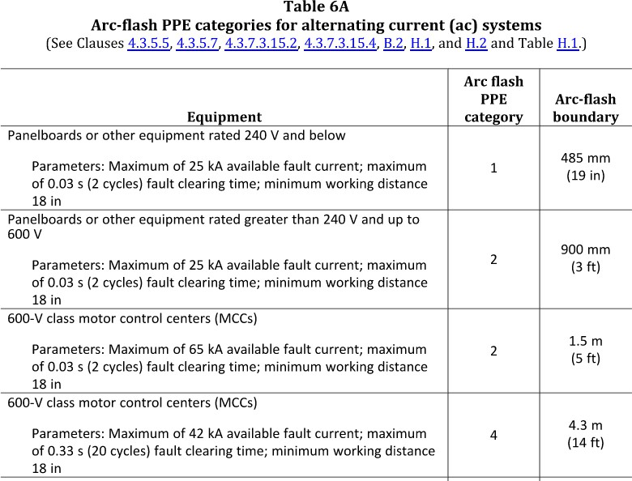
Table 6A – PPE

Table 6C – PPE

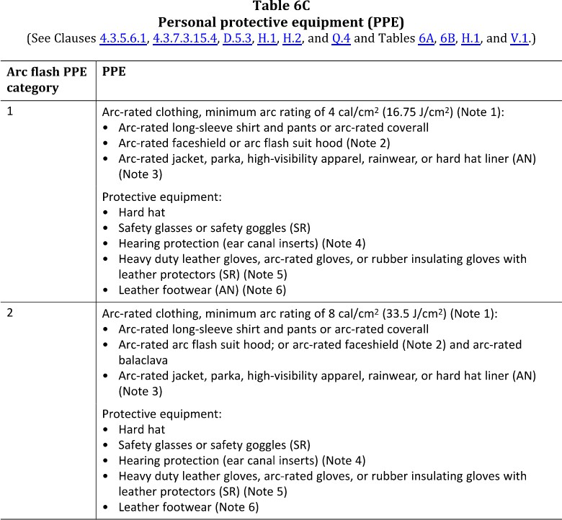

- Notes from CSA Z462:21 (Group, 2021)

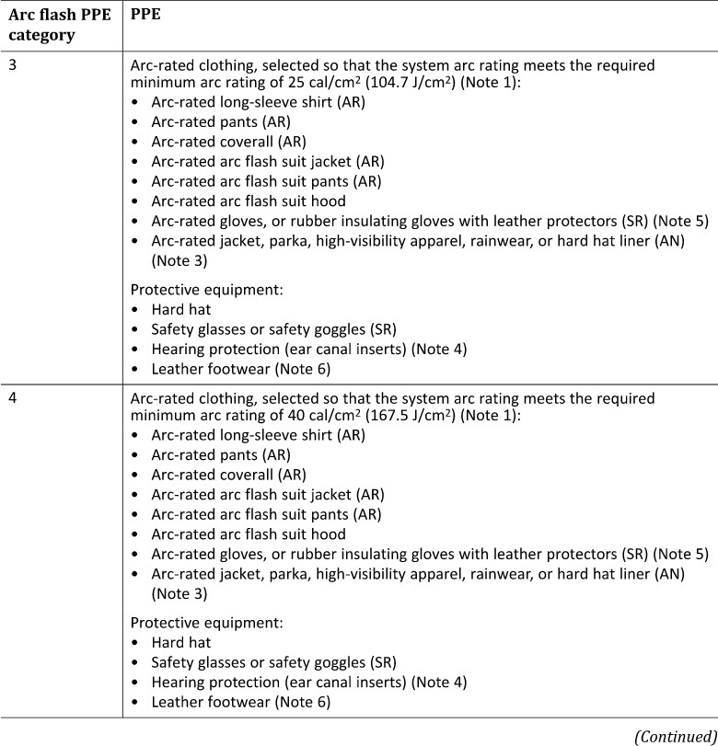
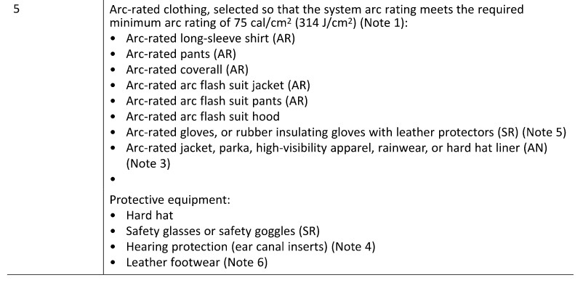

- Notes from CSA Z462:21 (Group, 2021)
Table O - Approach Distances

Nominal Voltage Range – Phase to Phase | Limited Approach Boundary  To Exposed Movable Conductor | Limited Approach Boundary  To Exposed Fixed Circuit Part | Restricted Approach Boundary
<30 V in Canada,  <50 V in the USA | Not specified | Not specified | Not specified
30 V –  150 V | 3.0 m  (10 ft) | 1.0 m  (3 ft 6 in) | Avoid contact
151 V –  750 V | 3.0 m  (10 ft) | 1.0 m  (3 ft 6 in) | 305 mm  (1 ft)
751 V –  15 kV | 3.0 m  (10 ft) | 1.5 m  (5 ft) | 0.7 m  (2 ft 2 in)
15.1 kV –  36 kV | 3.0 m  (10 ft) | 1.8 m  (6 ft) | 0.8 m  (2 ft 7 in)
Note: See CSA Z462, Table 1A for additional voltage ranges or NFPA 70E, Table 130.4(D)(a).

Approach Boundaries – DC Systems

Nominal Voltage Range – Phase to Phase | Limited Approach Boundary  To Exposed Movable Conductor | Limited Approach Boundary  To Exposed Fixed Circuit Part | Restricted Approach Boundary
<30 V in Canada,  <50 V in the USA | Not specified | Not specified | Not specified
(30 V in Canada or 50 V in the USA)  – 300 V | 3.0 m  (10 ft) | 1.0 m  (3 ft 6 in) | Avoid contact
301 V –  1 kV | 3.0 m  (10 ft) | 1.0 m  (3 ft 6 in) | 0.3 m  (1 ft)
1.1 kV –  5 kV | 3.0 m  (10 ft) | 1.5 m  (5 ft) | 0.4 m  (1 ft 5 in)
5.1 kV –  15 kV | 3.0 m  (10 ft) | 1.5 m  (5 ft) | 0.7 m  (2 ft 2 in)
15.1 kV –  45 kV | 3.0 m  (10 ft) | 2.5 m  (8 ft) | 0.8 m  (2 ft 9 in)

Table N – PPE, Tools, & Equipment
ES PPE, Tools & Equipment | Pre-Use Checks
Arc-rated Clothing | Must be clean, no dirt, no contamination due to chemicals, hydrocarbon stains, NO tears, rips, punctures, or frays of material. All zippers, buttons, snaps and Velcro must function properly and be covered by fabric.  Check for the proper arc rating (e.g. ATPV or E_{BT}) on the manufacturer’s labels on the inside of the garment. Check the correct size for the wearer.
Earplugs or Earmuffs | Ensure canal insert style earplugs are clean, inserted completely and are not damaged. Ensure earmuffs are made of non-conductive materials and that they are not damaged.
Hard Hat | No cracks, stickers, paint, not out of date, webbing and adjusting mechanism works, check harness for proper adjustment.  rinsing in clear water.  Ensure for electrical use that the hard hat is labelled Class E.
Rubber Insulating Gloves | Ensure hands are clean before inspecting, and fingernails are cut short. Store in a dry, cool location out of direct sunlight. Do not store them inside out. Store flat in the original manufacturer’s storage bag with the glove openings pointing into the bag.  Keep the rubber insulating gloves and leather protectors clean.  First check for a date stamp for testing to ensure current within the last 6 months, visually check for contamination, cracking, tears punctures and perform an air test to check for any leaks (e.g. roll up test or use a glove inflator pump. If you use a glove inflator pump do not over inflate the glove.). After the glove is full of air, listen for any leaks, check finger joints for cracks or wear, check for tears, punctures, cuts, ozone cutting or checking, embedded foreign objects and texture changes in the rubber, such as swelling, softening, hardening, sticky or inelastic.  Ensure the Class is adequate for working voltage (e.g. Class 0 for 600VAC). Use only approved rubber insulating glove talc/dust/powder.  Remove rubber insulating gloves from service if damaged.  Use with matching Class and Size of leather protectors. See ASTM F 1236 Standard Guide for Visual Inspection of Electrical Protective Rubber Products for specific details.  If you find that gloves are not suitable for use, cut off the fingers and discard.

Revisions
Revisions are completed as per (company) policy, and revisions are noted.
Version Revised | Worker conducting revision | Date
V3.2 revision 1

